Are these quantities correlated? Verify the concept of a linear dependence between these quantities.

Which data set shows the highest and which one the lowest correlation?



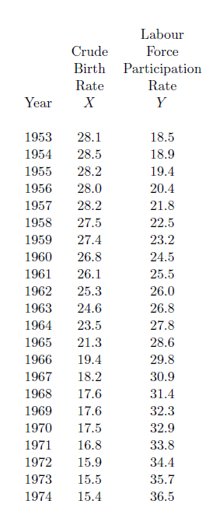



Multiple data

